Web Technologies Assessment:

B1.
<html>
<head>
<title>Student Registration</title>
<link rel="stylesheet" href="Style.css">
</head>
<body>
<h1>Student Registration Form</h1>
<p>Student registration form is very much important to verify student background and to grant access to the student</p>

<div class="form-container">
<form action="#" method="post">
<label for="fullname">Full Name:</label>
<input type="text" id="fullname" name="fullname" required><br><br>

<label for="email">Email:</label>
<input type="email" id="email" name="email" required><br><br>

<label for="dob">Date of Birth:</label>
<input type="date" id="dob" name="dob" required><br><br>

<label>Gender:</label><br>
<input type="radio" id="male" name="gender" value="Male">
<label for="male">Male</label><br>
<input type="radio" id="female" name="gender" value="Female">
<label for="female">Female</label><br>
<input type="radio" id="other" name="gender" value="Other">
<label for="other">Other</label><br><br>

<label>Languages Known:</label><br>
<input type="checkbox" id="english" name="languages" value="English">
<label for="english">English</label><br>
<input type="checkbox" id="hindi" name="languages" value="Hindi">
<label for="hindi">Hindi</label><br>
<input type="checkbox" id="tamil" name="languages" value="Tamil">
<label for="tamil">Tamil</label><br><br>

<label for="course">Course:</label>
<select id="course" name="course" required>
<option value="">--Select--</option>
<option value="BE">B.E</option>
<option value="ME">M.E</option>
<option value="MBA">MBA</option>
<option value="MCA">MCA</option>
</select><br><br>

<button type="submit">Submit</button>
</form>
</div>

<h2>Facilities</h2>
<ul>
<li>100+ clubs and forums</li>
<li>Experienced faculties</li>
<li>Modern infrastructure</li>
</ul>

<footer>
<p>&copy; Jagadeep, 2026</p>
</footer>
</body>
</html>

B2.
body {
background-color: #f0f4f8;
font-family: Arial, sans-serif;
margin: 0;
}

h1 {
color: #1F3864;
text-align: center;
font-size: 2rem;
border-bottom: 3px solid #1F3864;
}

form {
display: flex;
flex-direction: column;
width: 500px;
margin: 0 auto;
padding: 24px;
background: #ffffff;
box-shadow: 0 2px 8px rgba(0, 0, 0, 0.1);
}

input {
width: 100%;
padding: 8px;
margin-bottom: 12px;
border: 1px solid #cccccc;
border-radius: 4px;
}
@media (max-width: 600px) {
body {
padding: 12px;
}
form {
max-width: 100%;
}
}

Screenshot:
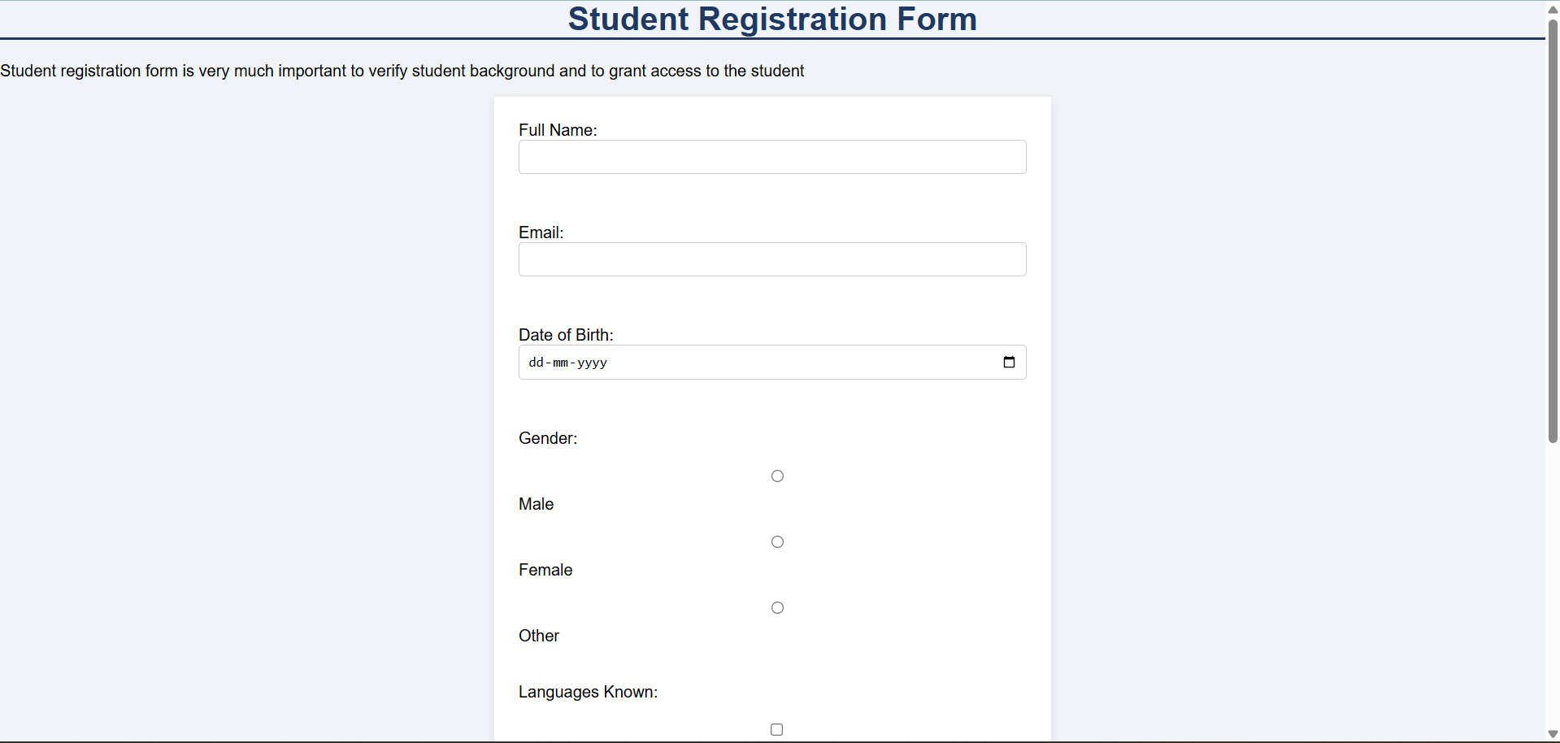

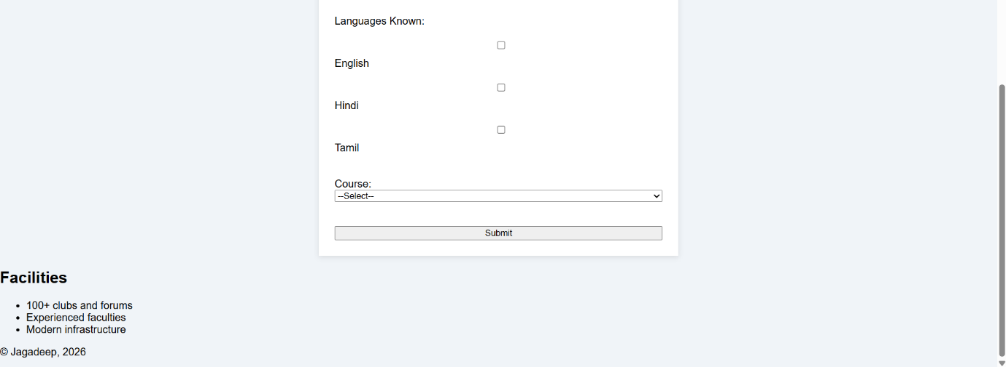

B3 - B3.1:
<html>
<head>
<title>Simple To-Do List</title>
<style>
body {
font-family: Arial, sans-serif;
text-align: center;
background-color: burlywood;
}
input {
padding: 8px;
width: 250px;
}
button {
padding: 8px;
}
ul {
margin-top: 20px; }
li {
margin-bottom: 10px;
padding: 1px;
border: 1px solid #ddd;
}
.delete-btn {
margin-left: 15px;
}
</style>
</head>
<body>
<h1>To-Do List</h1>

<input type="text" id="taskInput" placeholder="Enter a task">
<button id="addTaskBtn">Add Task</button>

<ul id="taskList"></ul>

<script>
const addTaskBtn = document.getElementById('addTaskBtn');
const taskInput = document.getElementById('taskInput');
const taskList = document.getElementById('taskList');

addTaskBtn.addEventListener('click', function() {

const taskText = taskInput.value;

const li = document.createElement('li');
li.textContent = taskText;

const delBtn = document.createElement('button');
delBtn.textContent = "Delete";
delBtn.className = "delete-btn";

delBtn.addEventListener('click', function() {
taskList.removeChild(li);
});

li.appendChild(delBtn);

taskList.appendChild(li);

taskInput.value = "";
});
</script>
</body>
</html>

Screenshot:
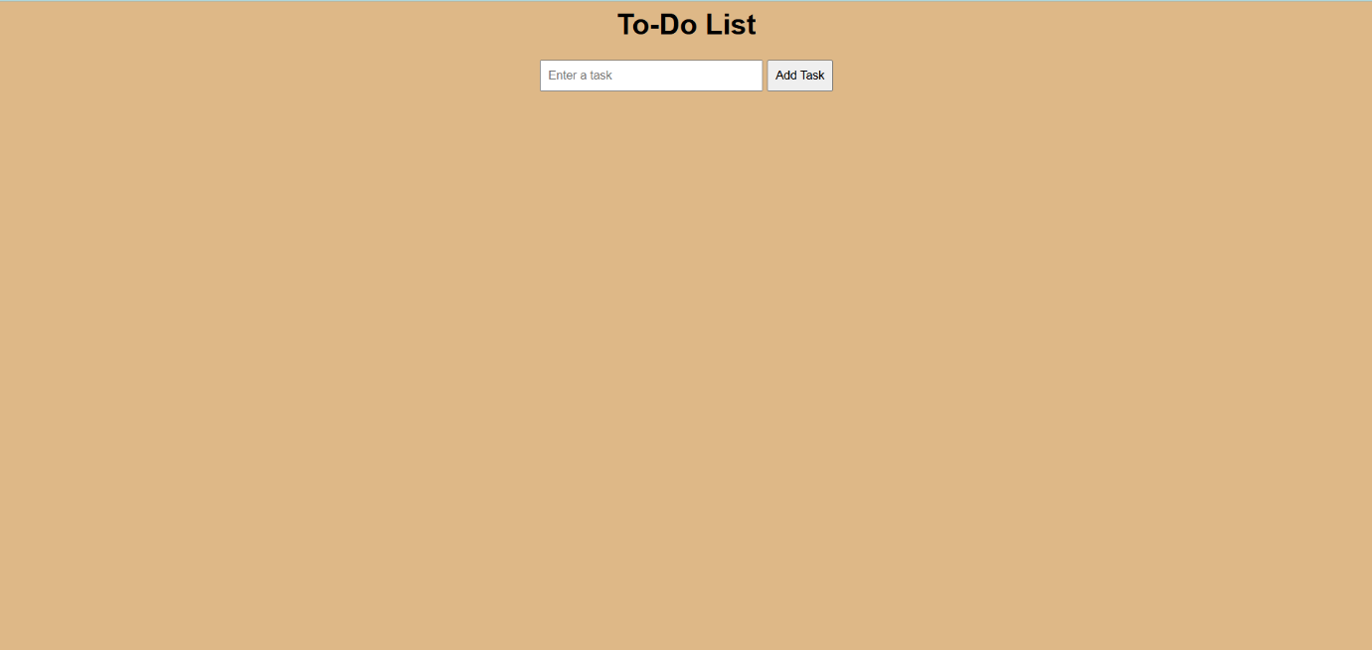

B3 – B3.2:
document.querySelector("form").addEventListener("submit", function(event) {
let isValid = true;

document.querySelectorAll("input, select").forEach(el => {
el.style.border = "";
});

const fullName = document.getElementById("fullname").value.trim();
if (fullName === "") {
document.getElementById("fullname").style.border = "2px solid red";
isValid = false;
}

const email = document.getElementById("email").value.trim();
if (!(email.includes("@") && email.endsWith(".com"))) {
document.getElementById("email").style.border = "2px solid red";
isValid = false;
}

const dob = document.getElementById("dob").value;
if (dob) {
const dobDate = new Date(dob);
const today = new Date();
if (age < 17) {
document.getElementById("dob").style.border = "2px solid red";
isValid = false;
}
}

});

